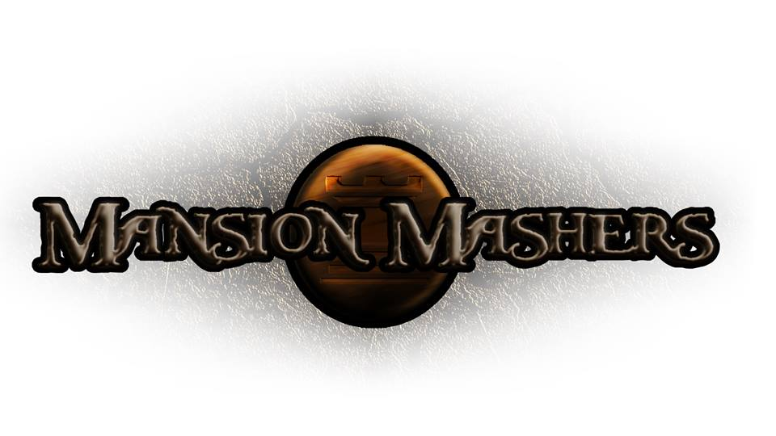**Weekly Production Report**

**Week 5**

**February 6, 2014**

**By Juli Gregg**

**High Concept**:

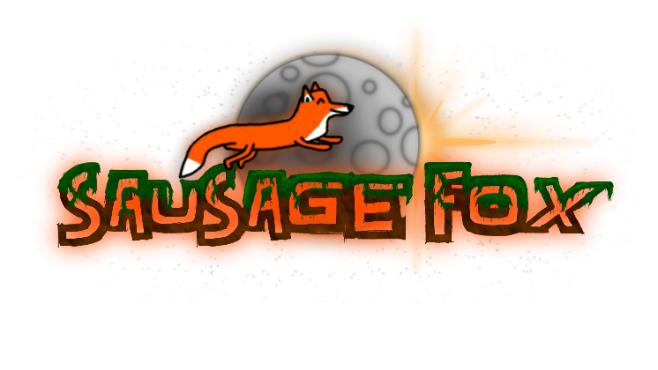A 2-D cartoon fantasy dungeon crawler side-scrolling hack and slash game.

**Producer:**

Juli Gregg

**Tech Director**:

Dan Muller

**Game Designer**:

Luke Conlon

**Project Manager**:

Kaden Nugent

Project Status:

Green

Current Milestone:

Engine Proof

Accomplishments:

|  |  |
| --- | --- |
| **Juli Gregg:** | Implemented FMOD functions to handle and manage sounds, channels, channel groups, pausing, and volume. As well as functions to setup, update, and release FMOD system. |
| **Dan Muller:** | Setup Pause menu, font/text creation and drawing. Updated player colliders and collision resolution. Worked on handling window resizing. Created a random weapon name generator. Is currently testing weapon swapping and is in the process of developing a tutorial level. |
| **Luke Conlon:** | Updated transformation positioning, rotation, and scaling to use matrixes. Fixed bugs in character animation and began work on enemy art designs. |
| **Kaden Nugent:** | Finished making the Object Manager handle actual objects and not just sprites. Is currently in the process of testing the Texture Manager and developing a Memory Manager. |

Objectives:

|  |  |
| --- | --- |
| **Juli Gregg:** | Map out levels on paper as well as begin to layout game objects/platforms in engine. Create functions for input and weave out using Alpha Engine for input reading. Finish PPD. |
| **Dan Muller:** | Plans to finish TDD and Tutorial level which includes picking up Buffs/enhancements and weapon informational pop-up text. Will work on weapon/enemy collision and resolution. |
| **Luke Conlon:** | Map out levels and begin working on Enemy/Boss logic. Continue to create art assets. |
| **Kaden Nugent:** | Finish Memory Manager and work on tutorial level for Engine Proof presentation. |

Group Accomplishments:

|  |  |
| --- | --- |
| **Weekly Group Meeting** | Together we went through and developed in depth character design for our two remaining bosses and basic enemy types. We began to plan out the last two weeks before Engine Proof presentations. |
| **Repository**  **Commit Stats** | This week: 86 commits  In a month: 333 commits |

Group Objectives:

|  |  |
| --- | --- |
| **Weekly Group Meeting** | Plan to go over and finish TDD and PPD. We will also discuss and decide on a format for Engine Proof presentations and also create a list of sound assets to give to Jason Uritescu who has offered to do sound for us. |

Highlights:

We are continuing to charge forward and remain ahead. A lot has been accomplished this week. There is excitement over what we will be able to show at our Engine Proof presentation.

Risks & Mitigations:

|  |  |
| --- | --- |
| **RISKS:** | (1) We have a lot of plans for this game that due to limited amount of time we may not be able to implement everything that we want to.  (2) The workload from other classes has begun to add up and has allowed for less time to work on game. |
| **MITIGATIONS:** | (1) Attempt to keep a realistic timeline and slowly weave in stretch goals as we achieve the basic requirements to make our game functional and fun.  (Ex. Multiplayer)  (2) Since we planned out our schedules together we are able to help one another and work more efficiently to get assignments done. |

**Signatures**

_____________________

Juli Gregg

_____________________

Dan Muller

_____________________

Luke Conlon

_____________________

Kaden Nugent